# Tugas Pemrograman Berorientasi Objek



**Muhamad Salman Adhim Baqy**

**A11.2020.12641**

**Fakultas Ilmu Komputer**

**Program Studi Teknik Informatika**

**Universitas Dian Nuswantoro**

**2022**

1. 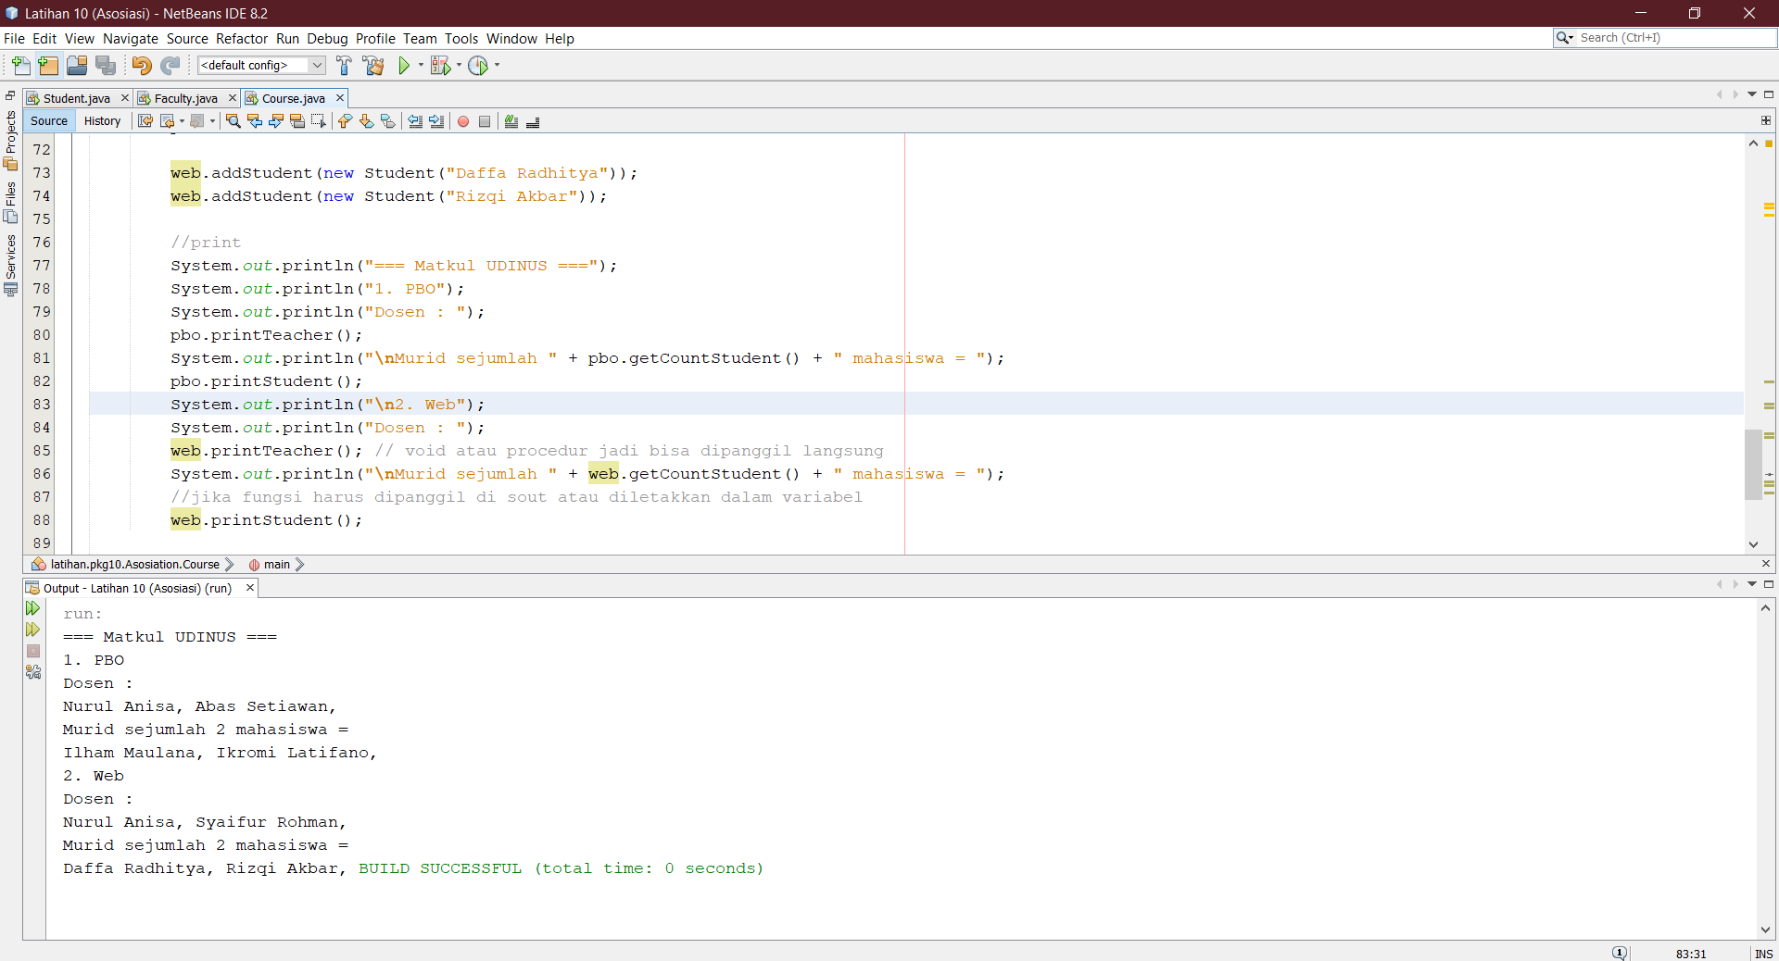Hasil Run

Student.java

|  |
| --- |
| /*  * To change this license header, choose License Headers in Project Properties.  * To change this template file, choose Tools | Templates  * and open the template in the editor.  */  package latihan.pkg10.Asosiation;  /**  *  * @author adhim  */  public class Student {  // atribute  private String name;  private Course[] listCourse = new Course[1000];  private int countCourse;    //method  public Student(String name){  this.name = name;  //punya class = inputan  }    public String getNameStudent(){  return name;  }  public void takeCourse(Course c){  listCourse[countCourse] = c;  countCourse++;  }  public Course[] getListCourse(){  return listCourse;  }  public int getCountCourse(){  return countCourse;  }    public static void main(String[]args){    }  } |

Faculty.java

|  |
| --- |
| /*  * To change this license header, choose License Headers in Project Properties.  * To change this template file, choose Tools | Templates  * and open the template in the editor.  */  package latihan.pkg10.Asosiation;  /**  *  * @author adhim  */  public class Faculty {  //atribute  private String teacher;  private Course[] listCourse = new Course[3];  private int countCourse;    //method  public Faculty(String teacher){  this.teacher = teacher;  }  public String getNameTeacher(){  return teacher;  }  public void teachCourse(Course c){  listCourse[countCourse] = c;  countCourse++;  }  public Course[] getListCourse(){  return listCourse;  }  public int getCountCourse(){  return countCourse;  }    public static void main(String[]args){    }  } |

Course.java

|  |
| --- |
| /*  * To change this license header, choose License Headers in Project Properties.  * To change this template file, choose Tools | Templates  * and open the template in the editor.  */  package latihan.pkg10.Asosiation;  /**  *  * @author adhim  */  public class Course {  // atribute  private String nameCourse;  private Student[] listStudent = new Student[60];  private int countStudent;  private Faculty[] listFaculty = new Faculty[3];  private int countFaculty;    //method  public Course(String nameCourse){  this.nameCourse = nameCourse;  }  public String getNamaCourse(){  return nameCourse;  }  public void addStudent(Student s){  listStudent[countStudent] = s;  countStudent++;  }  public Student[] getStudent(){  return listStudent;  }  public int getCountStudent(){  return countStudent;  }  public void setFaculty(Faculty f){  listFaculty[countFaculty] = f;  countFaculty++;  }  public Faculty[] getFaculty(){  return listFaculty;  }  public int getCountFaculty(){  return countFaculty;  }  public void printStudent(){  for(int i = 0; i < countStudent; i++){  System.out.print(listStudent[i].getNameStudent() + ", ");  }  }  public void printTeacher(){  for(int i = 0; i < countFaculty; i++){  System.out.print(listFaculty[i].getNameTeacher() + ", ");  }  }    public static void main(String[]args){  Course pbo = new Course("PBO"); //konstruktor nya ada inputan nama course  Course web = new Course("Web");    pbo.setFaculty(new Faculty("Nurul Anisa"));  pbo.setFaculty(new Faculty("Abas Setiawan"));    web.setFaculty(new Faculty("Nurul Anisa"));  web.setFaculty(new Faculty("Syaifur Rohman"));  //teacher adalah objek dari fakulti    //set student  pbo.addStudent(new Student("Ilham Maulana"));  pbo.addStudent(new Student("Ikromi Latifano"));    web.addStudent(new Student("Daffa Radhitya"));  web.addStudent(new Student("Rizqi Akbar"));    //print  System.out.println("=== Matkul UDINUS ===");  System.out.println("1. PBO");  System.out.println("Dosen : ");  pbo.printTeacher();  System.out.println("\nMurid sejumlah " + pbo.getCountStudent() + " mahasiswa = ");  pbo.printStudent();  System.out.println("\n2. Web");  System.out.println("Dosen : ");  web.printTeacher(); // void atau procedur jadi bisa dipanggil langsung  System.out.println("\nMurid sejumlah " + web.getCountStudent() + " mahasiswa = ");  //jika fungsi harus dipanggil di sout atau diletakkan dalam variabel  web.printStudent();    }  } |